UI/UX DESIGN · LAB ASSIGNMENT
Experiment 5
Heuristic Evaluation

GeM — Government e-Marketplace
Evaluation of the Tractors category interface captured in Experiment 4
Student | Shashwat Nande
Roll No. | 1032232121
Course | UI/UX Design (CSE4PE43A)
System | GeM — Government e-Marketplace (Tractors category)
Domain | Vehicles — agricultural machinery procurement
Date | 24 October 2026
Contents
Section | What it covers
Part I | Heuristic evaluation against 15 parameters with severity ratings (0–5) and improvements
Part II | Other observations beyond the given principles
Summary | Strengths and priority recommendations
Screenshots attached | The seven interface screens evaluated, one per page

Experiment 5 — Heuristic Evaluation

This experiment evaluates the GeM Tractors interface captured in Experiment 4 against 15 heuristic parameters. Each parameter is rated for the severity of any violation (0 = minimum severity, 5 = maximum severity) and paired with a practical way to improve it.

Scope and method
System evaluated | GeM (Government e-Marketplace) — Tractors category
Evaluated screens | Seven desktop screens: Home (hero), Home (popular category), Tractors listing, Bid detail, Specifications tab, My Bids, Help Centre (see Experiment 4, Figures 1–7)
Method | Heuristic evaluation against 15 parameters, each rated for severity of any violation from 0 (minimum) to 5 (maximum), with a suggested improvement
Limitations | Based only on the captured screens. The bid-participation form, the comparison view and mobile layouts were not captured, so these are noted as “could not be verified” rather than rated.

Severity scale
Rating | Meaning | Description
0 | No issue | No usability problem found.
1 | Cosmetic | Minor polish issue; fix only if time allows.
2 | Minor | Low-priority problem; slows some users slightly.
3 | Major | Important problem; fix with high priority.
4 | Serious | Blocks or frustrates many users; fix before release.
5 | Critical | Usability catastrophe; must be fixed immediately.

Part I — Heuristic evaluation based on the given principles
No. | Heuristic parameter | Observation / violation | Severity (0–5) | Ways to improve
1 | User Control | Strong control over discovery: removable filter chips (₹6–7 lakh, 40–50 HP, 2WD), Clear all, Reset, Sort, Compare checkboxes and Save for Later let users adjust their choices freely. However, after “Participation confirmed”, My Bids offers only View Bid Details — there is no visible option to edit or withdraw participation before the deadline. | 2 / 5 | Add Edit / Withdraw participation (with a confirmation step) until the bid closes, and an Undo option on the confirmation banner.
2 | Human Limitations | Key facts are chunked well (spec tiles, estimated-value card, four-stage tracker), so little has to be remembered. Load rises because filters appear in three places (Filters button, applied chips, sidebar) and because the Overview tab already shows technical specifications that also exist under a separate Specifications tab. | 2 / 5 | Keep one filter surface with an applied-filter summary; keep Overview for the summary and specifications in their own tab.
3 | Accommodation | Good provision for different users: A− / A / A+ text-size control, Hindi toggle, Skip to main content, visible keyboard-focus outline on navigation items and an Accessibility link in the footer. Gaps: only one additional language, no visible contrast mode, and several secondary labels (“Starting at”, “Upcoming”, “incl. applicable taxes”) are small and light grey. | 1 / 5 | Add more regional languages and a high-contrast toggle; raise small secondary text to at least 12 px with 4.5:1 contrast.
4 | Linguistic Clarity | Headings and microcopy are plain and friendly (“Tractors built for every field”, “How can we help?”), and the Help Centre explains EMD, BOQ and RA. However the same amount is “Starting bid value” on the listing but “Estimated procurement value” on the detail page, and stage names such as “Technical evaluation” and “Financial evaluation” are not explained where they appear. | 2 / 5 | Use one price label with the formal term in brackets; add tooltips on stage names that link to the glossary.
5 | Aesthetic Integrity | A consistent navy/orange identity on a warm neutral background, clear orange primary buttons, uniform cards and the Government of India bar give a credible, cohesive look. The weak point is imagery: the hero and tractor photos are generic stock images that do not show the named models. | 2 / 5 | Replace stock photos with OEM model images; give the hero image a product-relevant caption or featured model.
6 | Simplicity | The core path is short — Home → Products → View Bid → Participate → My Bids — and screens are uncluttered with generous white space. Minor redundancy: two search entry points (header Search and hero “Search all products”) and unused space below the specification table and in the Buyer information card. | 1 / 5 | Merge the search entry points and use the empty space for key bid facts such as EMD and bid validity.
7 | Predictability | Controls behave as labelled (View Bid, Participate in Bid, Save for Later) and the tracker shows what comes next. Surprises: the active Overview tab is headed “Technical specifications”, the “96% match” badge does not explain how it is calculated, and the Contact support card ends with “Read guide →”, which does not signal that it leads to a contact option. | 2 / 5 | Align tab names with their content, add a “Why this match?” tooltip, and label the Contact support action “Contact helpdesk →”.
8 | Accuracy | Specifications and prices agree across screens (48 HP, 1,700 kg, ₹6,70,000, bid no. GEM/2025/B/6128471). Issues: the bid shows a fixed closing date of 18 Jun 2025 beside a live-style “2 days 08 hrs remaining” countdown, which cannot both be true for a bid viewed in October 2026; and the tractor photos do not appear to match the models named (e.g. a vintage green tractor for Swaraj 744 FE). | 3 / 5 | Drive closing dates and countdowns from one source of truth; use verified OEM photos for every model.
9 | Technical Clarity | Listing cards show a consistent trio of spec tiles (HP, lift capacity, drive type) and the detail page adds cylinders, transmission, hydraulic lifting and warranty. Inconsistencies: the listing and detail summaries show different specs (drive type vs cylinders), lift capacity is also called “Hydraulic lifting”, and EMD, bid validity and an all-in cost breakdown are not visible in the captured screens. | 2 / 5 | Standardise one spec set and one naming scheme across card, summary and table; surface EMD, validity and all-in cost beside the price.
10 | Fulfillment | Participation takes few steps and gives clear closure: the eligibility banner (“You are eligible to participate”), the “Participation confirmed” banner with reference GEM-P-20431 and the four-stage tracker. Missing: the total value for the 4 units required (₹26,80,000), EMD status and a “what happens next” line on the confirmation. | 2 / 5 | Show total value and EMD status on the confirmation and add a next-steps line (e.g. date of technical evaluation).
11 | Consistency | Navigation, buttons, card styling and colours are consistent on every screen. Label inconsistency: the same action reads “View active bid →” on Home, “View Bid” on the listing and “View Bid Details” on My Bids; Compare is a checkbox on listing cards but “Add to compare” on the detail page; the price carries two different names. | 3 / 5 | Adopt one label for each action and concept (one View Bid, one Compare pattern, one price label).
12 | User Support | A dedicated Help tab with search, Bid glossary, How to participate, Notifications and Contact support cards, an info icon beside the price and a footer Help Centre link give good support. There is no contextual help inside the bid detail (match score, eligibility, evaluation stages) and no live-chat entry is visible. | 2 / 5 | Add contextual help links on the detail and My Bids pages and a visible helpdesk / chat entry.
13 | Precision | Budget, horsepower, drive type and brand filters, per-option counts and a clear result line (“14 active bids match your saved preferences”) let users narrow precisely. Limits: horsepower is a single 40–50 HP checkbox, the budget slider shows one handle for a range, there are no deadline, state or seller filters, and sorting defaults to the opaque “Best match”. | 2 / 5 | Provide a two-handle range slider, finer HP bands and deadline / location filters; explain what “Best match” means.
14 | Forgiveness | Filter mistakes are easy to undo (× on chips, Clear all, Reset) and Save for Later lets users defer a commitment. In the captured flow there is no confirmation step before participation is recorded and no visible way to undo or edit it afterwards; inline validation could not be verified from the screenshots. | 3 / 5 | Add a confirm dialog that summarises the bid, inline validation, and edit / withdraw until the deadline.
15 | Responsiveness | System status is communicated well: countdown banner, “Updated just now” on My Bids, the progress tracker and the “1 Active bid / 0 Action required” counters. Only desktop screenshots were captured, so mobile behaviour, loading states and error states could not be verified. | 2 / 5 | Test and document mobile layouts; add loading placeholders and clear messages for failed actions.
TOTAL SEVERITY SCORE |  |  | 31 / 75 | Lower is better (0 = no usability issues).
Overall assessment
The prototype scores 31 / 75 (lower is better), with no violation above severity 3. It has a strong, consistent visual identity, short task paths, reversible filtering, and good confirmation and tracking after participation. The main problems are data accuracy (a closing date that conflicts with the countdown, and photos that do not match models), inconsistent labels for the same action or amount, the lack of a confirm / withdraw step around participation, and limited contrast and language support.

Part II — Other observations (other than the given principles)
No. | Area observed | Observation | Suggested improvement
1 | Homepage hero | Clear value proposition (“The right tractor. The right bid.”), two CTAs, three trust cues and a “2,480+ active tractor listings” stat give a confident entry point. The hero photo is generic and not tied to a specific model. | Feature a real model or live bid in the hero so the image supports the message.
2 | Identity and accessibility bar | The Government of India strip with Skip to main content, A− / A / A+ and Hindi is a clear strength on the home screen. In the other captured screens the page was scrolled, so its persistence could not be confirmed. | Keep the bar (or a compact version) available on every page.
3 | Popular category cards | Cards are easy to scan (HP, drive type, starting price) but the photos do not match the model names and the link reads “View active bid →”, unlike the listing. | Use model-specific photos and the same link wording as the listing.
4 | Listing and filters | Match-percentage badges, spec tiles, verified OEM seller and delivery location make cards informative. Filters are repeated in three places and the match score is unexplained. | Consolidate filters into one panel and explain the match score.
5 | Bid detail summary | The dark closing banner, estimated-value card and eligibility message are strong. The Front / Side / Cabin buttons are text only (no thumbnails) and the closing date is inconsistent with the countdown. | Use thumbnail images for gallery views and correct the date / countdown source.
6 | Tabs and specification table | The specification table is clean and readable. The active “Overview” tab shows a “Technical specifications” heading, and the Buyer information card has unused space. | Rename or reorganise tabs; use the spare space for EMD, validity and documents status.
7 | Compare feature | Compare appears on listing cards and on the detail page (“Add to compare”), but the comparison view itself was not captured and the two labels differ. | Use one Compare pattern and verify the side-by-side view.
8 | My Bids dashboard | Counters, Manage Notifications and the four-stage tracker make status easy to understand. Tracker sub-labels (“Today”, “Upcoming”) are very small and pale. | Increase the size and contrast of tracker sub-labels.
9 | Help Centre | Four task-based cards with plain explanations and a search box. Icons are generic symbols (question mark, tick, diamond, telephone); the notification card uses a diamond rather than a bell, and Contact support says “Read guide →”. | Use recognisable icons and action-specific link text.
10 | Footer and sample content | The footer offers Help Centre, Accessibility and Terms with a clear mission line. Bid numbers and dates show 2025 while the session is in 2026, which looks stale. | Refresh sample dates and bid numbers so they look current.

Summary
Strengths
- Strong Government identity with a consistent navy / orange palette, clear primary buttons and uncluttered, card-based screens.
- Inclusive features visible on the home screen: text-size control, Hindi toggle, skip link and keyboard focus outlines.
- Precise, reversible filtering by budget, horsepower, drive type and brand, with applied-filter chips and a result count.
- Good closure after participation: eligibility message, confirmation banner with reference ID and a four-stage progress tracker.
- A task-oriented Help Centre with glossary, how-to guide, notifications and contact support.
Priority recommendations
Priority | Issue | Heuristics affected (severity) | Recommended fix
1 | Closing date conflicts with the countdown, and tractor photos do not match model names | Accuracy (3) | Single source of truth for dates and countdowns; verified OEM photos.
2 | Same action or concept carries different labels across screens (View Bid, Compare, price) | Consistency (3) | One label per action and concept; shared UI copy list.
3 | No confirmation before, or withdrawal after, participating in a bid | Forgiveness (3), User Control (2) | Confirmation dialog, inline validation, edit / withdraw until deadline.
4 | Filters and search appear in several places; range controls are limited | Human Limitations (2), Precision (2), Simplicity (1) | One filter panel, two-handle budget slider, deadline and location filters.
5 | Low-contrast small text and limited language support | Accommodation (1) | Raise contrast / size of secondary text; add regional languages and a contrast mode.

Screenshots Attached

The seven screens below were the basis of this evaluation (Homepage, popular category, tractors listing with filters, bid details, specifications, My Bids and Help Centre).

Screenshot 1 — Home page — hero and entry points
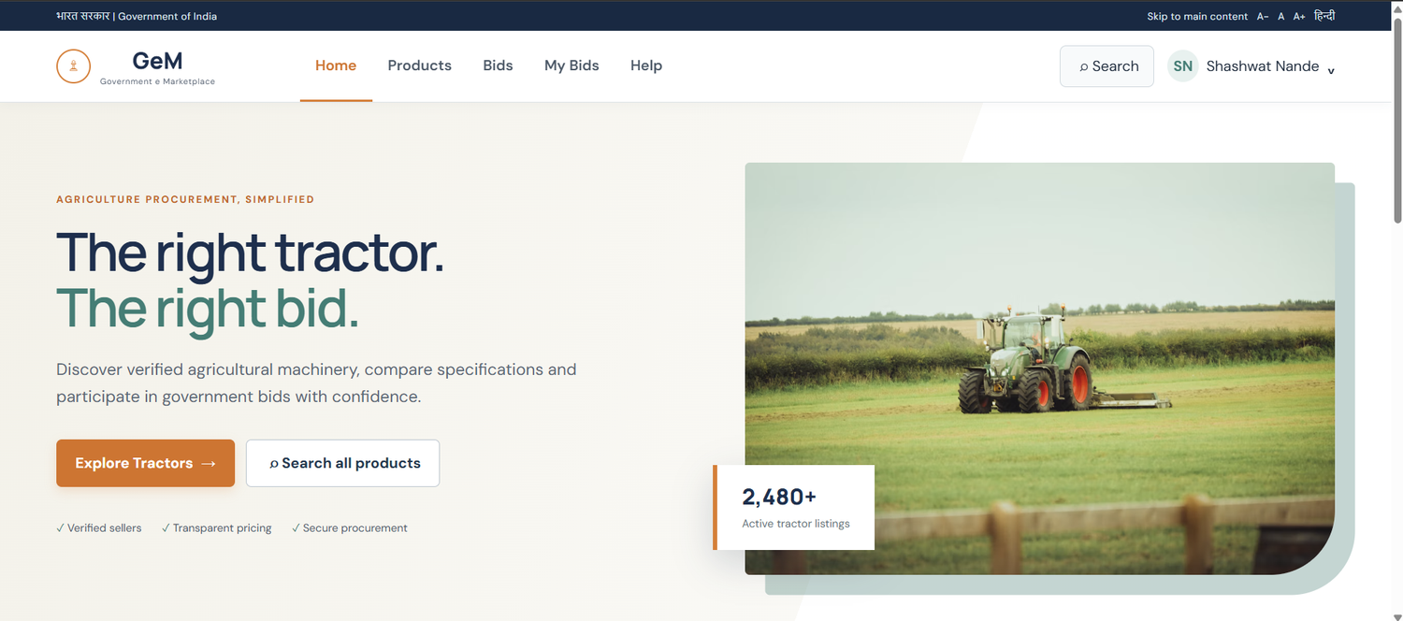
Screenshot 1: Home page — hero and entry points. Entry point of the portal; communicates the offer and routes buyers to tractors.

Screenshot 2 — Home page — popular tractor category
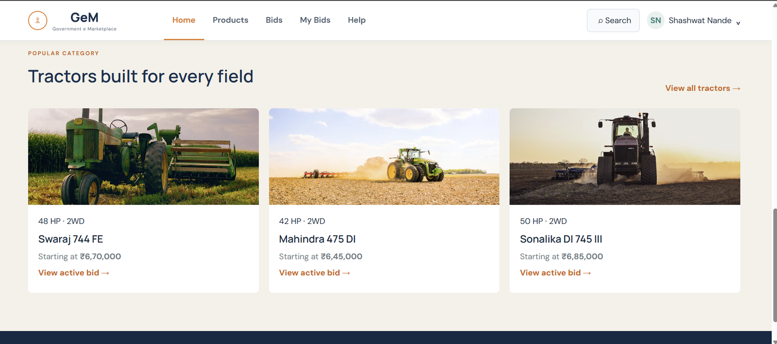
Screenshot 2: Home page — popular tractor category. Lets buyers jump straight into live tractor bids from the homepage.

Screenshot 3 — Tractors listing with filters
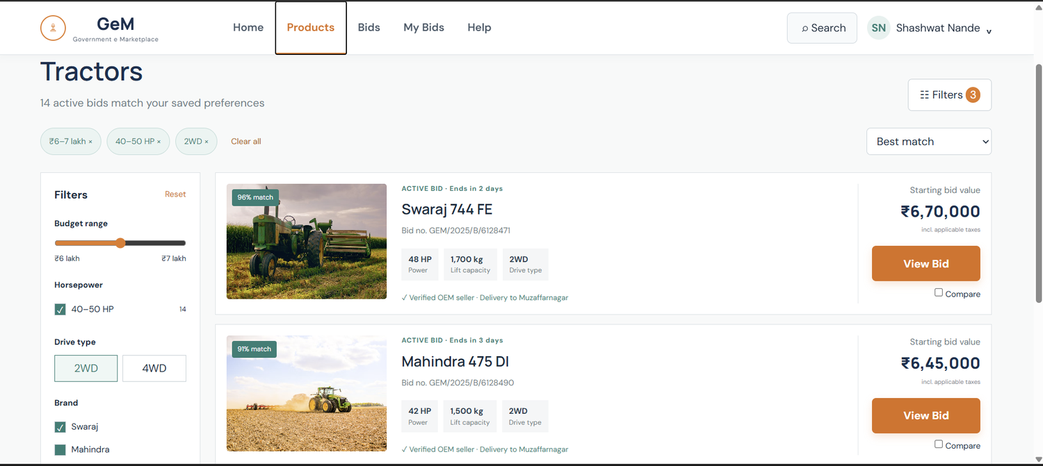
Screenshot 3: Tractors listing with filters. Narrow active tractor bids by budget, power and drive type, then shortlist or compare.

Screenshot 4 — Bid detail page
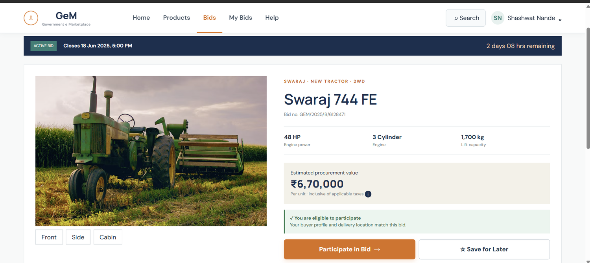
Screenshot 4: Bid detail page. Gives the full summary a buyer needs to decide whether to participate.

Screenshot 5 — Bid detail — technical specifications
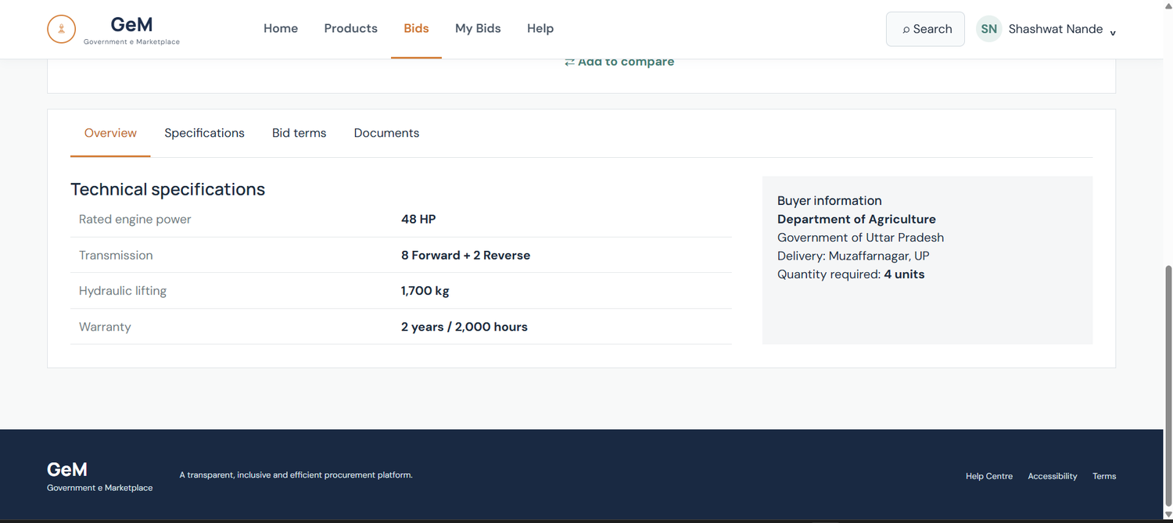
Screenshot 5: Bid detail — technical specifications. Presents detailed specifications and buyer context for the bid.

Screenshot 6 — Participation confirmation and My Bids
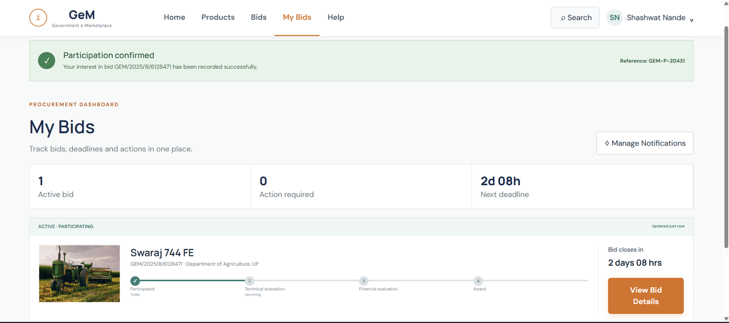
Screenshot 6: Participation confirmation and My Bids. Confirms participation and lets the buyer track progress without manual checking.

Screenshot 7 — Help Centre
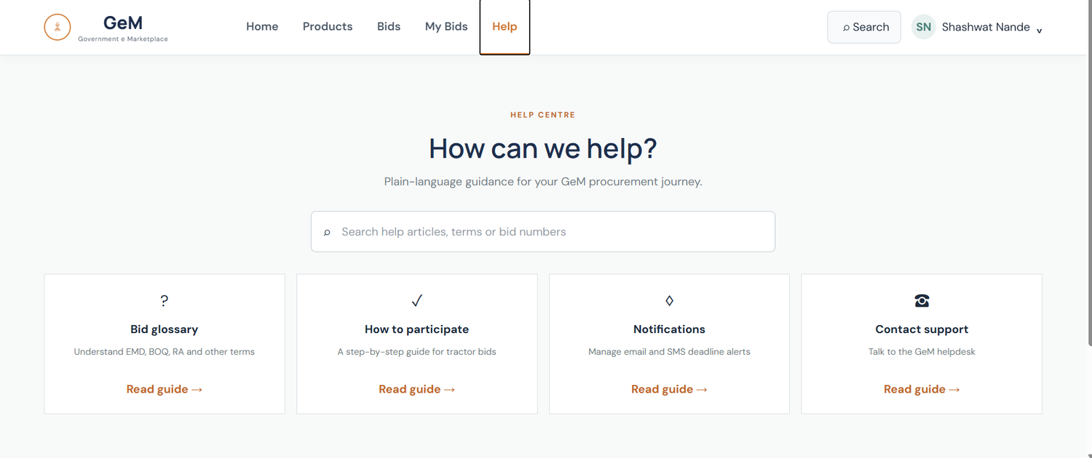
Screenshot 7: Help Centre. Plain-language support for first-time bid participants.

